**STEPS for running MoDaC on local.**

1. Before running MoDaC project, the required DME jars needs to be installed.

* Login to DME DEV server using ssh  [fsdsgl-dmeap01d.ncifcrf.gov](http://fsdsgl-dmeap01d.ncifcrf.gov/)
* Then sudo su - ncif-hpcdm-svc
* Navigate to the maven directory: cd ***/home/NCIF-HPCDM-SVC/.m2/repository/gov/nih/nci/hpc***
* Using scp command, download the required version of hpc-dto.jar from the folder “hpc-dto” to your local.
* Using scp command, download the required version of hpc-client.jar from the folder “hpc-client” to your local.
* Using scp command, download the required version of hpc-domain-types.jar from the folder “hpc-domain-types” to your local.

1. Now, run MoDaC project using the following steps:

* git clone the code from <https://github.com/CBIIT/nci-doe-data-sharing.git>
* git clone <https://github.com/CBIIT/nci-doe-data-sharing.git>
* In pom.xml, the API version is mentioned. Make sure the same version DME jars were downloaded in STEP 1.
* The local-env.conf is under src/main/resources/appconfigs.
* Add passwords in local-env.conf for MoDaC database, google drive client and secret Id, google captcha and service account passwords.
* In local-env.conf, point to the DME DEV Server (gov.nih.nci.hpc.server).
* *gov.nih.nci.hpc.server=https://fsdsgl-* *dmeap02d.ncifcrf.gov:7738/hpc-server*
* Install DME jars (hpc-client, hpc-dto and hpc-domain-types) from the base path (where pom.xml resides) using the following command:
* mvn install:install-file -Dfile=<path_to_hpc_client.jar> -DgroupId=gov.nih.nci.hpc -DartifactId=hpc-client -Dversion=<api_version> -Dpackaging=jar
* mvn install:install-file -Dfile=<path_to_hpc_dto.jar> -DgroupId=gov.nih.nci.hpc -DartifactId=hpc-dto -Dversion=<api_version> -Dpackaging=jar
* mvn install:install-file -Dfile=<path_to_hpc_domain_types.jar> -DgroupId=gov.nih.nci.hpc -DartifactId=hpc-domain-types -Dversion=<api_version> -Dpackaging=jar

**OPTION 1: To deploy and run using terminal:**

* To do a maven build from terminal, use the following commands, build the project from base path (where the pom.xml resides):
* mvn eclipse:clean
* mvn eclipse:eclipse
* At this step, if the ojdbc6 jar missing error is seen, download the jar and install the jar at the directory where the pom.xml resides using the following command.
* mvn install:install-file -Dfile=<path_to_ojdbc6 jar> -DgroupId=com.oracle -DartifactId=ojdbc6 -Dversion=11.2.0 -Dpackaging=jar
* mvn clean install -DskipTests
* Now run the project using the following:
* cd to target folder and run the following command:
* Java -Xdebug -Xrunjdwp:transport=dt_socket,address=9991,server=y,suspend=n -jar <web-doe-1.15.0.war>

**OPTION 2: Using eclipse IDE**

* To do the maven build from eclipse, right click on the project and do Run As🡪 Run Configurations.
* Click on “Maven Build” and set up run configurations as attached in the screenshot.

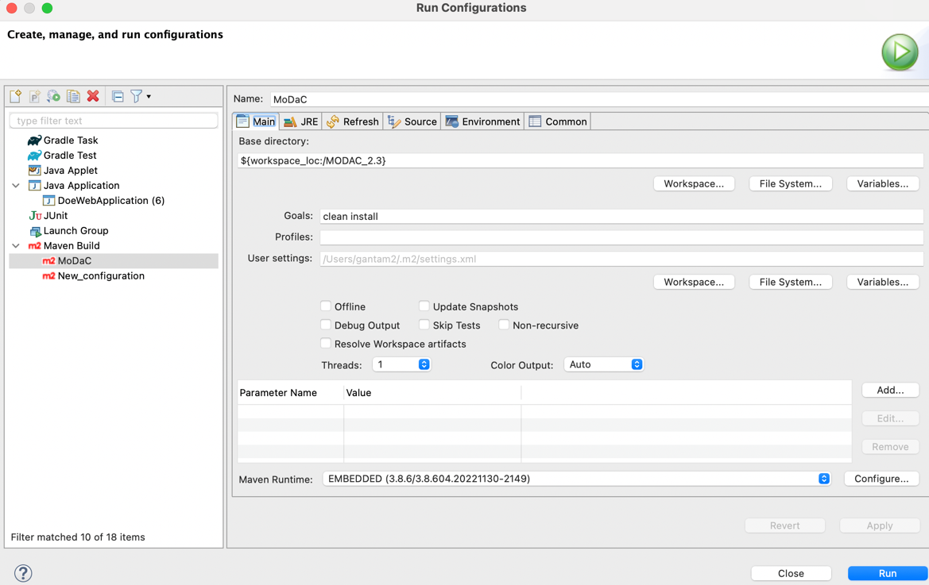

* At this step, if the ojdbc6 jar missing error is seen, download the jar and install the jar at the directory where the pom.xml resides using the following command.
* mvn install:install-file -Dfile=<path_to_ojdbc6 jar> -DgroupId=com.oracle -DartifactId=ojdbc6 -Dversion=11.2.0 -Dpackaging=jar
* To start the Project using eclipse, Right click on the project and click Run As🡪 java application and select DoeWebApplication (which is the main class).